ECONOMICS YEAR 11

SEMESTER ONE EXAMINATION

2001

INSTRUCTIONS TO CANDIDATES

TIME ALLOWED: Reading 10 Minutes
Working of Paper 3 Hours

This paper is divided into THREE (3) sections:

PART A Multiple Choice: Mark your answers on the answer sheet provided.

Part A Worth 30 marks – allow approx 30 minutes.

PART B Short Answers: Answer all 3 questions on the space provided in the exam paper.

Part B Worth 45 marks (3 x 15 Marks) – allow approx 50 minutes

PART C Essay Answer: Three extended essay style answers. This should be no longer than two pages of normal writing.

Part C Worth 75 marks (3 x 25 Marks) – allow approx 100 minutes

Remember to hand in your exam paper with your answer booklet
at the end of the exam. Make sure your name is on all pages.
PART A: MULTIPLE CHOICE

Answer ALL questions on the answer sheet provided. Do not mark this exam paper in any way. ALLOW APPROX 30 MINUTES for this part.

- If all the resources of a country are fully employed

- It may still be possible to increase material welfare
- Welfare is at a maximum
- Optimum production has been achieved
- There is not economic problem

- The economist does NOT assume that

- People are motivated solely by money
- Some goods are scarce for each person
- People exhibit wants for a multitude of goods
- People are motivated by the desire to improve their material welfare

- In an open economy injections into the circular flow of income include increases in

- Taxes
- Government expenditure
- Savings
- Imports

- When confronted with the choice of building a by-pass for $2 million or building two schools at $1 million each the government decided on the latter. The opportunity cost of this decision was:

- The by-pass
- $2 million
- $1 million
- It is not possible to tell

- Which one of these statements is true?

- The problem basic to economics is inflation
- Choice is necessary because of limited wants
- The means to satisfy wants, that is the factors of production, are limited
- The basic economic problem has changed since the Great Depression

- Which one of the following is NOT an economic problem?

- Deciding between extra paid work and extra leisure
- Deciding between expenditure on one good or another good
- Deciding on the level of personal saving
- Deciding between different ways of spending leisure time

- “If I didn’t have a date tonight, I would save $20 and spend this evening playing dungeons and dragons.” The opportunity cost of the date is:

- $20
- $20 plus the cost of foregoing a night playing dungeons and dragons
- Dependent on how pleasant a time one has on the date
- The cost of foregoing a night playing dungeons and dragons.

- The distinguishing characteristic of an economic good is

- That it is scarce
- That it is sold in the market place
- That resources must be used to produce it
- The consumer derives utility from owning it

- Different societies have evolved different methods of tackling the economic problem but while their methods are different one ultimate aim appears to be the same. That aim is

- To make their country richer than all other countries
- To make the best possible use of their available resources
- To achieve equality of incomes
- To provide their consumers with the widest possible range of consumer goods and services.

- In a free enterprise Capitalist society, the allocation of the factors of production among the various productive activities is determined by:

- The traditional employment of the factors
- The needs of the country
- Decisions of the Government
- The pattern of consumers’ spending

- In a planned economy the economic problem of what shall be produced is determined primarily by:

- Direction by the Government
- People producing directly to satisfy their own wants
- The pattern of consumers’ spending
- The independent decisions of entrepreneurs

- Which of the following statements are true?

- Income flows because everyone’s income is someone else’s expenditure
- Income flows because everyone’s expenditure is someone else’s income
- Investment adds to the flow of income
- Saving adds to the flow of income

- All four statements
- 1, 2, 3
- 3, 4
- 1.

- Which of the following does NOT describe interest, rent and a wage rate?

- Each is a price
- Each is an income to some and a cost to others
- Each is a payment to a factor of production
- Each is a reward for entrepreneurship

- In a circular flow diagram the money households receive comes from

- The sale of labour resources by householders to firms
- The sale of capital resources by households to firms
- The sale of the productive services of land by households to firms
- All of the above

- The conventionally accepted law of consumer behaviour (as phrased by Keynes) may be correctly expressed as follows

- As income increases, people increase consumption proportionally
- People increase their consumption as their income increases but not as much as the increase in their income
- People increase their savings as their income increases, not their consumption
- One person’s consumption expenditure is another person’s income

- In an open economy injections into the circular flow of income include increases in

- Taxes
- Government expenditure
- Savings
- Imports

- Consumer sovereignty means that

- Consumers are protected against defective goods and certain sales techniques.
- Only consumers can determine the distribution of a nation’s product
- Consumers’ decisions, concerning their allocation of income, largely determine the nature of production
- The actions of consumers in the market place largely affects demand and supply, and therefore the price, of goods and services

- If a demand curve shifts this could be the result of

- A change in price
- A change in the conditions governing supply
- A change in taste patterns
- A change in the market equilibrium

- Compared to the price-elasticity of demand for petrol in general, the demand for a particular brand of petrol is

- Inelastic because demand for each brand keeps on rising as population grows and becomes more affluent
- Inelastic because in the short term there is no effective substitute for petrol
- Elastic because if the relative price of one brand rose, customers would buy other brands which are close substitutes
- Elastic because if the relative price of one brand fell, sellers of the other brands also would reduce their price

- A good is inferior

- If demand for it falls as income rises
- If demand for it falls as price falls
- If it is substituted for by other goods as its price falls
- If less of it is demanded as years of economic growth go by

- A supply curve will generally take an upwards sloping form from left to right because

- A producer’s average costs decrease as output increases
- The Law of Diminishing Returns applies
- Market price normally exceeds average cost of production
- Consumers’ incomes tend to increase in the long run

- The supply of wool and the supply of lamb/mutton may be inter-related because they are:

- Complementary
- Competitive
- In joint supply
- Perfectly inelastic

- “Market equilibrium” is achieved

- Only after government intervention
- At a price at which the amount willingly supplied and the amount willingly demanded are equal
- When there is an equal number of consumers and producers in the market
- When there is not shortage of the commodity

- The price system

- Sets up incentive for firms to produce what consumers want
- Determines each person’s income through the prices of his resources
- Both of the above
- None of the above

- Public goods are those which

- Are supplied free by the government
- Are consumed collectively by the community
- People buy without realising that they will not get satisfaction from them
- Are produced by a public enterprise as distinct from a public or proprietary company

- Collective, or public, goods are those which

- If made available to one must be made available to all
- Are made available free of charge although they can be priced
- Are produced by governments
- Are financed from income tax

- Externalities cause the competitive market mechanism to allocate goods and resources inefficiently because

- Third parties always will be hurt by the effects of externalities
- The signals given by the competitive market will be ignored by producers and consumers
- Prices always will be higher than they should be
- The competitive markets will fail to give producers and consumers correct signals

- Police protection is provided free by the government because

- Police protection could not possibly be financed through the price system
- If it were not provided free, only the rich could afford protection
- Otherwise there would be no police force
- In a competitive market the standard of police protection would not reach socially desirable levels

- A pure market economy is unlikely to provide a sufficient amount of a public good such as a national defence because

- Consumers are poorly informed as to the value of national defence
- It is impossible to prevent non-paying customers from receiving national defence
- National defence does not yield a benefit to individuals
- Private firms will be less efficient than public firms in producing a public good such as national defence

- If the production possibility curve for two goods shifts so that it moves further from the origins throughout its length, this could be due to

- A decline in the level of unemployment
- An increase in productivity of a factor of production
- An increase in consumer demand for both goods
- A substitution of capital for labour using given production processes.

END OF SECTION A

Go directly to the next section of the paper
SECTION B: SHORT ANSWERS
Attempt ALL questions in the spaces provided.

- (15 Marks)

THE MARKET FOR MANGOES
Price $ | Quantity of mangoes demanded | Quantity of mangoes supplied
2.00  2.50  3.00  3.50  4.00  4.50 | 20,000  15,000  12,000  10,000  9,000  8,000 | 2,000  7,000  12,000  16,000  18,000  20,000

- Using the demand and supply schedule above construct a fully labeled diagram showing the market supply and demand for mangoes on the grid provided.

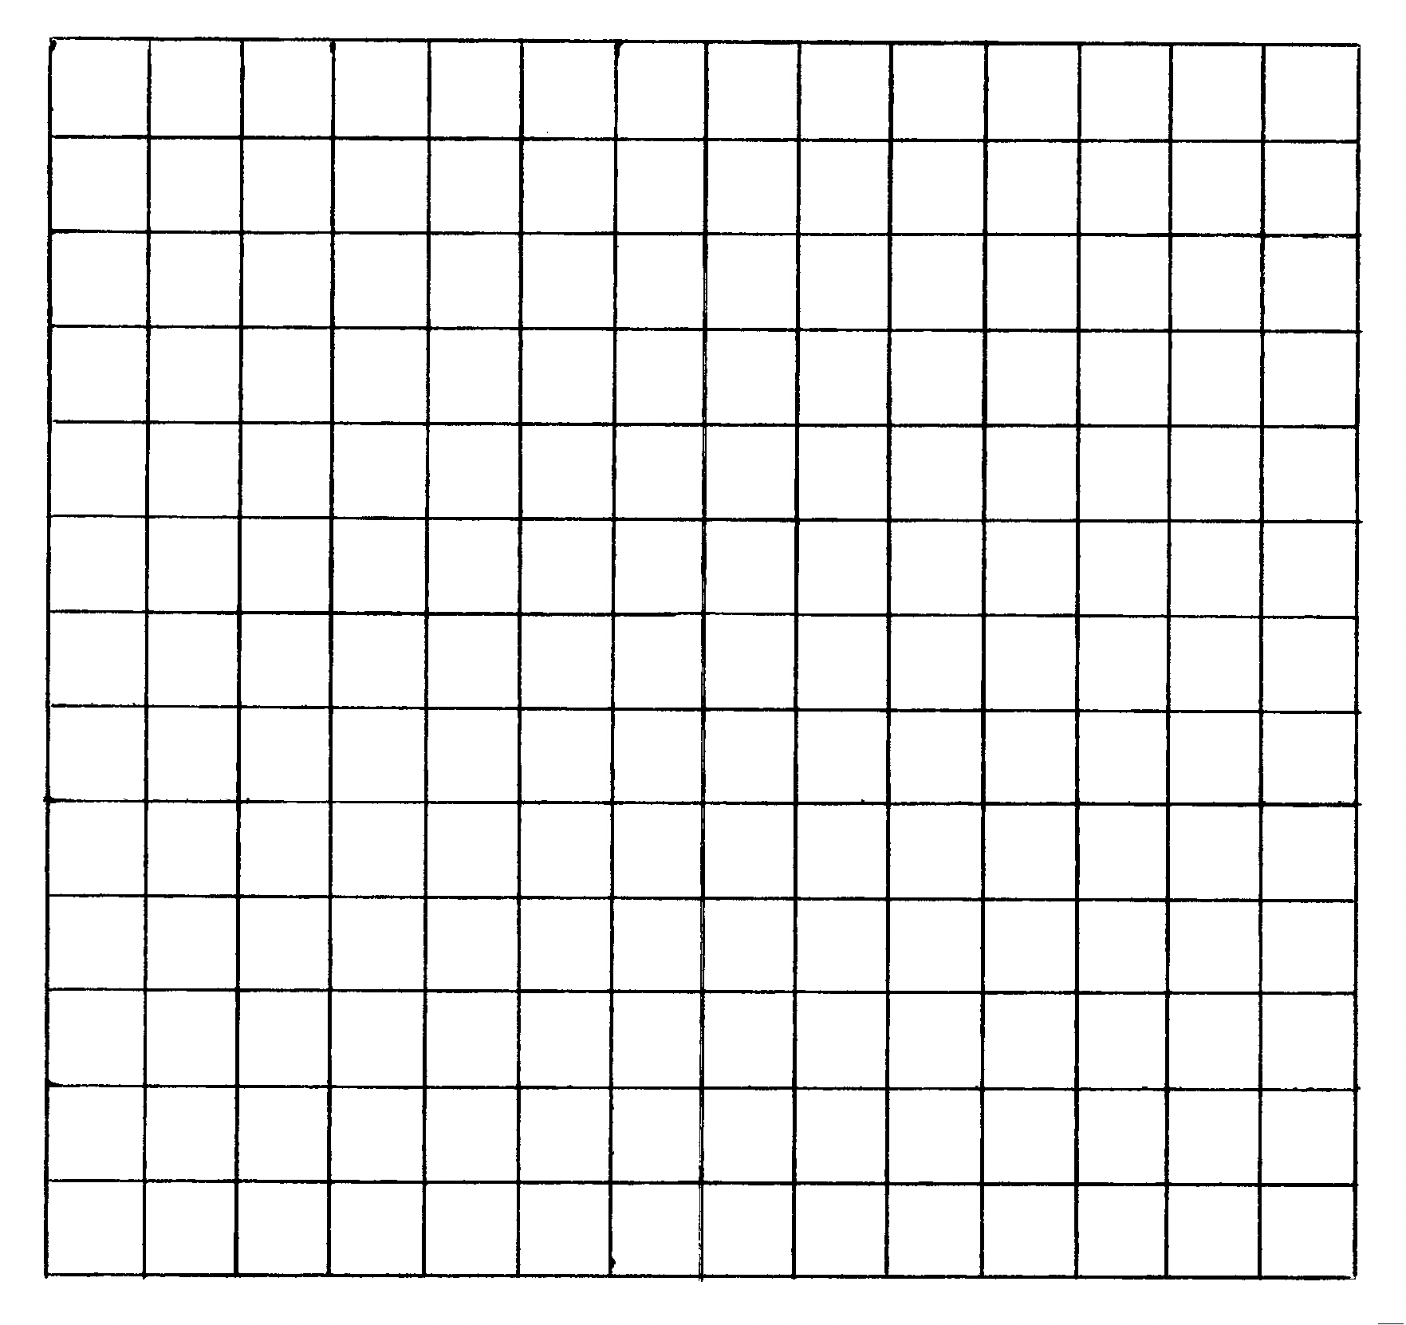
(4 Marks)

- Explain and demonstrate with a diagram, the effect of a rise in income on the market for mangoes.

_______________________________________
_______________________________________
_______________________________________
_______________________________________
_______________________________________
_______________________________________
(3 Marks)

- Show with a diagram an explain situations where shortages and surpluses occur.

_______________________________________
_______________________________________
_______________________________________
_______________________________________
_______________________________________
_______________________________________

_______________________________________
_______________________________________
_______________________________________
_______________________________________
_______________________________________
_______________________________________
(8 Marks)

- (15 Marks)

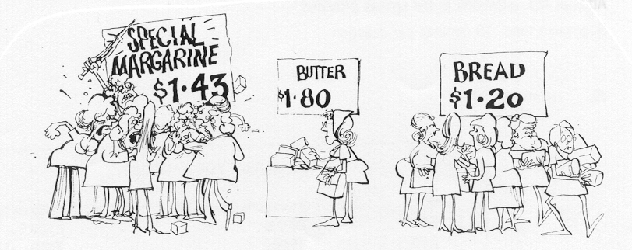

  - Is the demand for margarine elastic or inelastic? Explain your answer with reference to the above cartoon. (4 Marks)

__________________________________________________________________________
__________________________________________________________________________
__________________________________________________________________________
__________________________________________________________________________
__________________________________________________________________________
__________________________________________________________________________
__________________________________________________________________________
__________________________________________________________________________

  - Use the information in the table below to explain why a knowledge of elasticity may be useful to both the government and firms. (6 Marks)

Industry | Elasticity
Airline travel  Spirits  Household appliances  Furniture  Entertainment  Beer  Tobacco  Confectionery  Road transportation  Bread and cakes | 2.25  1.84  1.48  1.46  1.12  0.77  0.48  0.40  0.18  0.12

_________________________________________________________________________
_________________________________________________________________________
_________________________________________________________________________
_________________________________________________________________________
_________________________________________________________________________
_________________________________________________________________________
_________________________________________________________________________
_________________________________________________________________________
  - In November 1994, the Australian newspaper issued a report entitled ‘Accountants gain from skill scarcity’. The report indicated that a shortage of skilled graduates and in increase in demand for accountancy services has resulted in salary increases of up to 20% in the profession.

Using this information, discuss the short-term and long-term elasticity of supply of accountants. Why may this knowledge of elasticity be of interest to companies employing accountants? (5 Marks)

_____________________________________________________________________________
_____________________________________________________________________________
_____________________________________________________________________________
_____________________________________________________________________________
_____________________________________________________________________________
_____________________________________________________________________________
_____________________________________________________________________________
_____________________________________________________________________________
- Match the definition and terms shown below. (15 Marks)

Term | Definition
A Regressive taxation  B Exchange Rate  C Social Wage  D Balance of payments of accounts  E Public good  F Economic growth  G Natural monopoly  H Indexation  I Recession  J Consumer price index  K Participation rate  L Structural unemployment | - A tax system where the incidence of tax takes a bigger proportion of income of relatively high income households.  - People who lose their job due to a combination of a change in the pattern of economic activity and a lack of their ability to move into new areas of work.  - The price of the Australian dollar expressed in terms of one or more other currencies.  - The value of goods and services, received by a household, which has been provided by the government for free or at a reduced cost.  - An indicator of inflation, showing the level of cost of living for an average employment based metropolitan household.  - An indicator that summarises the movements of finance between Australia and the rest of the world.  - A period of negative economic growth or economic contraction, officially for two successive three-month periods.  - A collective good, where the exclusion principle does not operate.  - An industry where there is a single producer because the economies of scale of the industry are such that it is only possible for one producer to be efficient.  - Adjustment of economic data for the rate of inflation.  - The proportion of the population between 15 and 65 that are in the labour force.  - The measured rise in the level of production or output in an economy over a given period of time.

PART C ESSAY ANSWERS :

Choose and Answer any Three, each worth 25 Marks

Write your answers in the answer booklet provided, ensuring that you start each answer on a new page.

The answers should be between no longer than two pages of normal writing.

- Construct a model of the Circular Flow and explain the role of Leakages and Injections, in determining total output, employment and economic growth. (25 marks)

OR

2. i. What is meant by the term ‘equilibrium’? (2 Marks)
- Where does Market equilibrium occur? (8 Marks)
- What happens in markets when the price is above and below the equilibrium price? (15 Marks)

OR

3. i. What are the four (4) economic objectives of Government? (10 Marks)
ii Explain fully why price stability ought to be a major responsibility in a
capitalist economy. (15 Marks)

OR

4. i. What is meant by privatization? (5 Marks)
- Outline and discuss the advantages and disadvantages of privatization. (20 Marks)

OR

5. Explain how and why income is re-distributed in Australia (25 Marks)

OR

6. i. Diagram and discuss the various responses of consumers and produces to
change in price. (10 Marks)
- Diagram and discuss how changes in the underlying determinants of supply and demand may effect market equilibrium. (15 Marks)

OR

7. Discuss the benefits and limitations of the market system. (25 Marks)

OR

8. i. Describe Australia’s recent pattern in international trade. (15 Marks)
- Why is it important for Australia to engage in international trade? (10 Marks)

END OF EXAMINATION

STUDENT NAME_______________________________

WARNBRO COMMUNITY HIGH SCHOOL



ECONOMICS YEAR 11

SEMESTER ONE EXAMINATION

2001

ANSWER BOOKLET

Section | Marks
A
 | 1.
B | 2.
 | 3.
 | 1.
C | 2.
 | 3.
TOTAL | /100

Name……………………………………………………………

ANSWER SHEET FOR QUESTIONS 1 TO 30

Question  Number | Answer |  |  |  |  | Question  Number | Answer
1 | A | B | C | D |  | 16 | A | B | C | D
2 | A | B | C | D |  | 17 | A | B | C | D
3 | A | B | C | D |  | 18 | A | B | C | D
4 | A | B | C | D |  | 19 | A | B | C | D
5 | A | B | C | D |  | 20 | A | B | C | D
6 | A | B | C | D |  | 21 | A | B | C | D
7 | A | B | C | D |  | 22 | A | B | C | D
8 | A | B | C | D |  | 23 | A | B | C | D
9 | A | B | C | D |  | 24 | A | B | C | D
10 | A | B | C | D |  | 25 | A | B | C | D
11 | A | B | C | D |  | 26 | A | B | C | D
12 | A | B | C | D |  | 27 | A | B | C | D
13 | A | B | C | D |  | 28 | A | B | C | D
14 | A | B | C | D |  | 29 | A | B | C | D
15 | A | B | C | D |  | 30 | A | B | C | D

